

“Operational Modelling of Technology Enabled Treatment Adherence Monitoring”

Astha Jakher

Second Year Undergraduate Student

Indian Institute of Technology, Kharagpur

Under the guidance of:

Prof. Sarang Deo

Associate Professor, Operations Management, Indian School of Business

Executive Director, Max Institute of Healthcare Management

**Context :**

In 2016, 423000 deaths in our country were caused due to Tuberculosis, making it India’s most life consuming disease. Although the number of new tuberculosis (TB) cases, the world's deadliest infectious disease, continued to decline in 2017, India accounts for 27% of the 10 million people who developed the disease in 2017, according to the World Health Organization's (WHO's) 2018 Global TB report.

Non-adherence to anti tuberculosis treatment is one of the crucial challenges in improving tuberculosis cure-rates and reducing further healthcare costs. Given the context of India, non-adherence to TB medications is a rampant problem due to low literacy rates and rural areas not having readily available medical clinics and centers in proximity.

In India, the use of Directly Observed Therapy (DOT) in the public sector has been associated with high treatment success. However, direct observation introduces challenges for patients and providers, who need to undertake frequent travel throughout the course of treatment. It is also challenging for program managers to detect and respond to missed doses in an accurate and timely way. An alternative approach to ensuring medication adherence is via use of medication monitors that track each dose dispensed. For example, in China, an electronic medication monitor was recently shown to improve adherence to TB medications by 43%.

Far from a technology-centric intervention, medication monitors are effective due to behavioral support: reminders to patients, monitoring by care providers, and automatic outreach to social networks. However, current medication monitors are prohibitively expensive, often costing up to $100 per device. Until now, their benefits have been out-of-reach for low-income patients in the developing world.

In May 2014, various charity organizations and Tuberculosis research centres launched one of the most convenient and efficient medication tracking methods for TB patients- 99DOTS.

Patient medication is packaged in custom secondary envelopes which add dosage instructions and a series of hidden numbers behind the pill.

Each time the patient takes the medicine, a hidden number is revealed which is unpredictable to the patient.



The revealed number completes a phone number, where the first part of the number is printed on the front side of the envelope. The patient then makes a free call to the completed phone number.



There is maintained, a large array of phone numbers which are packaged in an unpredictable way to the patients, and the only way for a patient to call the correct number is to dispense the pills. Therefore, there is a high confidence they have taken their medication for the day. With this real-time information, reminders, incentives, and additional counseling can be decided for those patients with low adherence.

**Our Objective:**

After having the information of the days and pattern of missing the call of the patients, various ways of tackling the cases of low adherences can be employed. Regular phone call reminders and text messages could be the first line of action. Paying a visit to the patient if the days of him missing the call have crossed a level, beyond which there is a threat to him, would be the next step.

Our goal is to study various aspects of these field visits like the average time a patient will have to wait before being visited and the average number of patients that are pending to be visited by the field agent. Our concern is to keep a track of dosing implementation and make sure that the field visits make the required impact.

These observations are going to provide us a vague idea about the patterns of change in the factors like average waiting time and dosing implementation with the factors that we can vary. Conclusively, we will realise that even though in certain circumstances, it might be operationally convenient to increase the patients under a field officer, we might want to not go ahead because the health impact on population would turn out to be adverse.

**Methodology:**

The simulation starts with a field agent who is allocated a random number of patients daily (following a Poisson distribution) who have entered the TB treatment that day and add up to the patients that are under his care.

Every patient stays under the care of the field agent throughout the duration of his treatment (8 months). During this period, the simulation oversees his/her behaviour towards the medication and decides if he/she needs to be paid a visit by the field agent. If he/she needs a visit, the simulation places him/her in the queue of the patients needing attention and we calculate the time till which the patient gets visited by the agent.

The overall system can be shown as this-



Inputs in the model:

|  |  |  |  |
| --- | --- | --- | --- |
| INPUT | VALUE | DESCRIPTION | SOURCE |
| total_time | 2000 | The days for which the simulation runs for one field agent. | Manually observed so as to by what time is the steady state attained in the system |
| ST_rate | 1/7 | The number of days per patient takes to be visited. Here, for instance, the field  agent visits 7 people in one day. | Assumption |
| num_total | variable | The number of patients that we expect to have in our system at steady state. |  |
| treatment_time | 100 | The days for which a patient stays in the system.  (Taken less than regular value to make it computationally quick) | WHO (240 days) |
| IAT_rate | variable | IAT_rate= treatment time/num_total | Little’s Law |
| thresh | variable  (3/7/10 Days) | The number of consecutive missed days after which the patient is added to the queue of the patients who need a field visit | Assumption |
| addh | Variable  (0.45/0.5/0.55) | The average adherence of the patients towards TB medication in that region. It varies from region to region and can be changed according to the time and requirement. | Assumption |
| P_miss_Add | 0.78 | This is the probability of the patient not calling the number behind the tablet after taking  the medicine | Preliminary 99DOTS Accuracy Results (N=500) |
| P_miss_noAdd | 0.93 | This is the probability of the patient not calling the number behind the tablet given that he has not taken the medicine | Preliminary 99DOTS Accuracy Results (N=500) |
| p_th | 0.847 | Daily expected adherence | Assumption |

Random distributions used in model:

|  |  |  |
| --- | --- | --- |
| VARIABLE | DISTRIBUTION | DESCRIPTION |
| No. of patients entering the simulation each day | Poisson | Mean= IAT_rate  a1=np.random.poisson(1/IAT_rate) |
| No. of field visits made each day | Poisson | Mean= ST_rate  a2=np.random.poisson(1/ST_rate) |
| Adherence of a patient (P_miss) | Bernoulli | Each day there is an equal probability of the patient being adherent to the medication and this is independent of the past history (except when the field visit has been made to him)  temp = np.random.binomial(a1,addh)/a1  P_add.append(temp)  P_miss.append(P_miss_Add*P_add[i]+ P_miss_noAdd*(1-P_add[i])) |

Flow of the simulation-





We keep a record of the missed days, the waiting time, adherence, the probability of

having missed a medicine, the number of days the person has spent inside the simulation and other information in lists for all the patients who have ever been a part of

the simulation model.

**Step 1**:

We randomly determine the number of patients who will be entering the system this

particular day and the number of patients that the field agents will be capable of visiting

on the same day.

a1=np.random.poisson(1/IAT_rate)

a2=np.random.poisson(1/ST_rate)

We enter the a1 in out list of patients that keeps a record of how many days these

patients have been in the system. After increasing all the previous patients’ days of

presence by 1, it initialises the new patients presence time to 1 day.

We also randomly assign the probability of adherence to every patient in the system-

temp = np.random.binomial(a1,addh)/a1

P_add.append(temp)

Once we are aware of the P(adherence) for each patient and we know P(miss|no

adherence) and P(miss|adherence), we can calculate P(miss) for all the patients in the system.

P(add) was recently determined by binomial distribution and other two, as previously

stated, are experimental value.

For the patients who have already been visited, the P(add) is set to 1.

P_miss.append(P_miss_Add*P_add[i]+ P_miss_noAdd*(1-P_add[i]))

**Step 2**:

Once we know the P(miss)for each patient, we can compare it with the threshold

probability and determine if the person has actually missed the medication that day or

not.

If the person has missed the medicines for the previous two times also and this day is

the day when he/she crosses the threshold, this person is entered into the Simul_me

list that enters all these elements into a queue.

**Step 3**:

If the capacity of the field agents for this particular day is a2, the first a2 elements of the

queue are taken out of the queue and a visit is made to them. All these patients who have been visited have their index numbers stored in visited ​ so that they can be checked and their adherence can be assigned 1 from now on.

The remaining patients that needed a field visit and were a part of the queue are pushed

forward into the queue for the visit of the next day. One day is added to their waiting time too. In case they aren’t visited next day also due to limited field visits on the next day, their waiting time is again incremented by 1 and they are pushed forward for the next day until they are actually visited and removed from the queue.

**Step 4**: The same procedure is followed for different number of patients and various patterns are noted in the output they follow.

**Dry Run (Simulation of system- step by step):**

Pattern of the dry run output (sequentially) :

* Number of Patients
* Total days the patient has spent in the simulation (only those in simulation who<100)
* Total missed days of all the patient out of Total days spent
* Consecutive missed days (eg, 2 means it’s the 2nd miss in row)
* List of patients of these indexes have been visited
* Adherence of the patients (Note that after a visit, the adherence becomes 1)

100

[1]

[1]

[1]

[]

[0.0]

100

[2, 1, 1]

[2, 0, 1]

[2, 0, 1]

[]

[0.0, 0.6666666666666666, 0.0]

100

[3, 2, 2, 1, 1, 1, 1]

[3, 1, 1, 0, 1, 1, 1]

[3, 1, 0, 0, 1, 1, 1]

[]

[0.42857142857142855, 0.2857142857142857, 0.5714285714285714, 0.5714285714285714, 0.42857142857142855, 0.42857142857142855, 0.42857142857142855]

100

[4, 3, 3, 2, 2, 2, 2, 1]

[4, 2, 1, 1, 1, 1, 1, 1]

[0, 2, 0, 1, 0, 0, 0, 1]

[0]

[1, 0.125, 0.75, 0.375, 0.625, 0.625, 0.875, 0.375]

100

[5, 4, 4, 3, 3, 3, 3, 2, 1, 1]

[4, 3, 2, 2, 1, 2, 2, 2, 0, 1]

[0, 3, 1, 2, 0, 1, 1, 2, 0, 1]

[0]

[1, 0.5, 0.5, 0.4, 0.9, 0.4, 0.4, 0.3, 0.7, 0.5]

100

[6, 5, 5, 4, 4, 4, 4, 3, 2, 2, 1]

[4, 4, 2, 2, 2, 3, 2, 3, 0, 2, 1]

[0, 0, 0, 0, 1, 2, 0, 3, 0, 2, 1]

[0, 1]

[1, 1, 0.6363636363636364, 0.6363636363636364, 0.5454545454545454, 0.5454545454545454, 0.7272727272727273, 0.36363636363636365, 0.7272727272727273, 0.45454545454545453, 0.5454545454545454]

**.**

**.**

**.**

**.**

**.**

**.**

**.**

**.**

**.**

100

[53, 52, 52, 51, 51, 51, 51, 50, 49, 49, 48, 47, 46, 46, 46, 44, 43, 43, 43, 43, 41, 41, 39, 35, 35, 35, 35, 35, 34, 34, 33, 33, 32, 31, 30, 29, 28, 27, 27, 26, 24, 24, 23, 22, 20, 20, 20, 19, 19, 19, 18, 16, 16, 13, 10, 9, 5, 3, 1]

[4, 4, 20, 21, 15, 5, 8, 4, 9, 4, 7, 19, 12, 7, 7, 18, 15, 9, 14, 11, 7, 17, 7, 14, 19, 13, 18, 14, 4, 4, 7, 6, 9, 16, 4, 10, 12, 6, 8, 14, 7, 8, 5, 4, 11, 7, 11, 6, 7, 6, 11, 6, 8, 8, 4, 4, 1, 1, 0]

[0, 0, 0, 3, 0, 0, 0, 0, 0, 0, 0, 0, 0, 0, 0, 1, 0, 0, 0, 0, 0, 0, 0, 0, 0, 0, 2, 0, 0, 0, 0, 0, 0, 0, 0, 0, 0, 0, 0, 2, 0, 1, 0, 0, 0, 0, 1, 0, 0, 0, 3, 0, 0, 0, 2, 1, 0, 0, 0]

[0, 1, 7, 5, 9, 6, 14, 8, 13, 20, 10, 28, 29, 22, 19, 31, 34, 4, 12, 17, 30, 43, 16, 42, 18, 32, 37, 40, 35, 11, 21, 27, 47, 45, 33, 51, 53, 24]

[1, 1, 0.576271186440678, 0.4576271186440678, 1, 1, 1, 1, 1, 1, 1, 1, 1, 1, 1, 0.5084745762711864, 1, 1, 1, 1, 1, 1, 1, 0.6440677966101694, 1, 0.576271186440678, 0.4576271186440678, 1, 1, 1, 1, 1, 1, 1, 1, 1, 0.6440677966101694, 1, 0.559322033898305, 0.5084745762711864, 1, 0.5084745762711864, 1, 1, 0.559322033898305, 1, 0.5254237288135594, 1, 0.576271186440678, 0.559322033898305, 0.5254237288135594, 1, 0.6610169491525424, 1, 0.4406779661016949, 0.4576271186440678, 0.576271186440678, 0.6271186440677966, 0.576271186440678]

100

[54, 53, 53, 52, 52, 52, 52, 51, 50, 50, 49, 48, 47, 47, 47, 45, 44, 44, 44, 44, 42, 42, 40, 36, 36, 36, 36, 36, 35, 35, 34, 34, 33, 32, 31, 30, 29, 28, 28, 27, 25, 25, 24, 23, 21, 21, 21, 20, 20, 20, 19, 17, 17, 14, 11, 10, 6, 4, 2]

[4, 4, 20, 22, 15, 5, 8, 4, 9, 4, 7, 19, 12, 7, 7, 18, 15, 9, 14, 11, 7, 17, 7, 15, 19, 14, 18, 14, 4, 4, 7, 6, 9, 16, 4, 10, 13, 6, 9, 14, 7, 8, 5, 4, 11, 7, 12, 6, 7, 7, 11, 6, 8, 8, 4, 5, 1, 2, 0]

[0, 0, 0, 0, 0, 0, 0, 0, 0, 0, 0, 0, 0, 0, 0, 0, 0, 0, 0, 0, 0, 0, 0, 1, 0, 1, 0, 0, 0, 0, 0, 0, 0, 0, 0, 0, 1, 0, 1, 0, 0, 0, 0, 0, 0, 0, 2, 0, 0, 1, 0, 0, 0, 0, 0, 2, 0, 1, 0]

[0, 1, 7, 5, 9, 6, 14, 8, 13, 20, 10, 28, 29, 22, 19, 31, 34, 4, 12, 17, 30, 43, 16, 42, 18, 32, 37, 40, 35, 11, 21, 27, 47, 45, 33, 51, 53, 24, 3]

[1, 1, 0.5932203389830508, 1, 1, 1, 1, 1, 1, 1, 1, 1, 1, 1, 1, 0.5932203389830508, 1, 1, 1, 1, 1, 1, 1, 0.5254237288135594, 1, 0.5423728813559322, 0.6101694915254238, 1, 1, 1, 1, 1, 1, 1, 1, 1, 0.5084745762711864, 1, 0.4576271186440678, 0.559322033898305, 1, 0.5932203389830508, 1, 1, 0.559322033898305, 1, 0.5423728813559322, 1, 0.559322033898305, 0.5254237288135594, 0.6101694915254238, 1, 0.559322033898305, 1, 0.6610169491525424, 0.4576271186440678, 0.7627118644067796, 0.3898305084745763, 0.559322033898305]

There are 2000 such observations made for 100 patients and graphs are obtained like these-

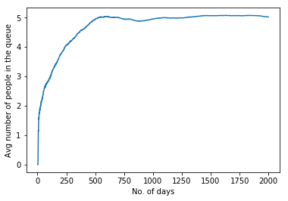.....(a)

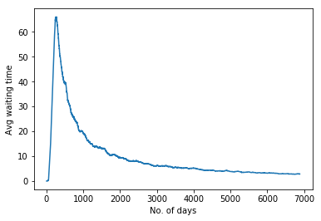......(b)

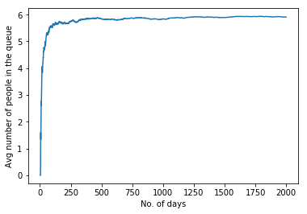.......(c)

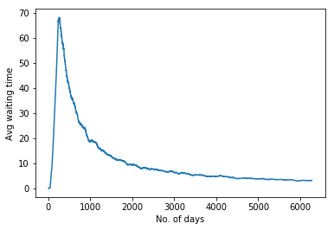.....(d)

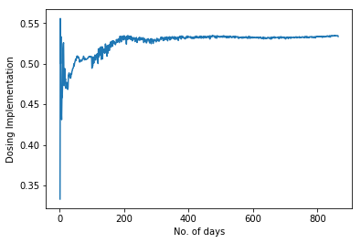......(e)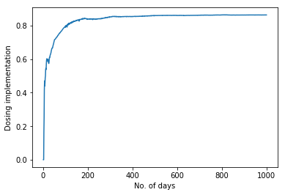.......(f)

The above graphs represent the values of the factors we’ve taken on Y-axis with the passage of time.

As the simulation starts, the Field Officer gets a few patients each day and for the first 240 days (or 100 days, depending on the input of simulation), there are no exits from the system. This causes the patient count to increase every day until it reaches a steady state where the number of patients leaving the system (due to completion of treatment) are approximately equal to the number of patients entering the system. At this stage, we have almost a fixed number of patients in the simulation. This makes the average waiting time, the average queue length and dosing implementation steady.

While analysing these values for different number of patients, we are interested only in the steady state where the values stop changing drastically with every passing day. We create several such sample paths for a specific patient count and take the average steady state values for these.

[NOTE: The above few graphs are only to show pattern and have been obtained under different conditions]

(e) is for 10 patients and (f) is for 100 patients (with the same initial conditions as stated in ‘methodology’)

(a),(b),(c),(d) are for cases where treatment time is 240 days, service rate is ¼ and inter-arrival rate is close to 1.

**Graphical Observations:**

1. **Adherence**

*Average Queue Length:*

As we increase the patients we have in the steady state, the rate at which the average queue length increases rises in an exponential fashion.

The service rate for all these observations is a constant and so is the average time for which the patients remain in the system.

Therefore, as the number of patients at steady state increases, the rate at which people enter the queue also increases in accordance with the Little’s Law.

Adherence of the patients directly affects their chances of missing the medicines-

P_miss.append(P_miss_Add*P_add[i]+ P_miss_noAdd*(1-P_add[i]))

An adherent population would see lesser number of patients undergoing the treatment, miss their medication consecutively for three days. This would imply that lesser patients would require a FO’s visit. The rate at which these patients enter the field officer's service queue go down and this decreases the average queue length.

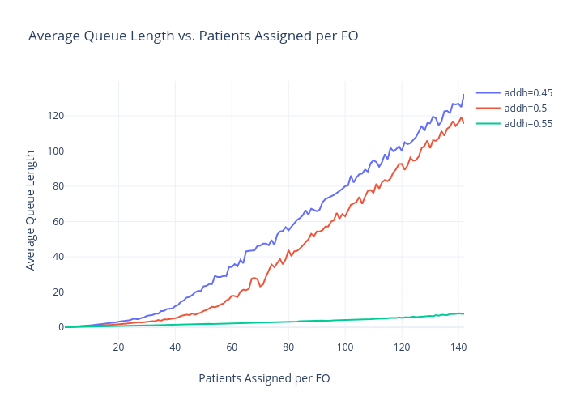

*Average Waiting Time:*

Low adherence will spike the number of people with consecutive misses. As more and more people cross the threshold and enter the queue of field visits, there are going to be more people waiting for their turn to come.

This will cause an increase in the overall waiting time of patients.

As the number of patients rise, the arrival is going to be more rapid and would again lead to an increase in the length of the FO’s visiting queue and also the average amount of time a person spends in the queue before being visited by the field agent.

This causes the curve of average waiting time exponentially increasing and the significant gap between average waiting times of patients with different adherences.

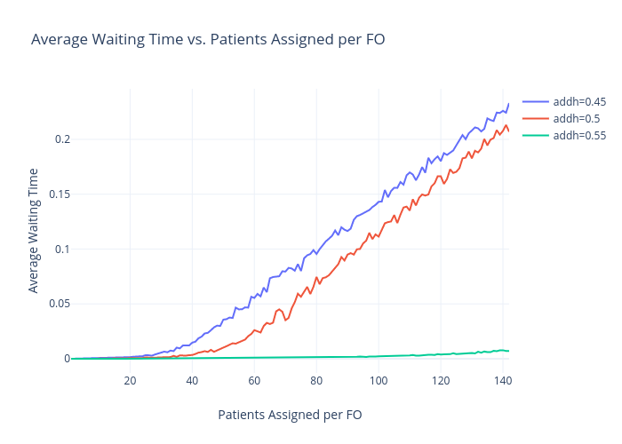

*Dosing Implementation:*

We define dosing implementation as-

Dosing Implementation = No. of patient days of medicine taken/ Total patient days

The dosing implementation reflects the efficiency of the system in increasing the patient days of medication taken. It practically depends on only one thing- Adherence.

The way the other features alter adherence determine the impact they have on Dosing Implementation. As the adherence decreases, more and more patients miss their medicines and thereby cause an overall decline in the Dosing Implementation.

As the number of patients increase, the lesser will be the rate at which a field visit could be made to them and hence they will have a lesser chance of becoming fully adherent due to delay and overcrowding in the queue. Thus, as the number of patients under the care of a field agent increases, the dosing implementation goes down.

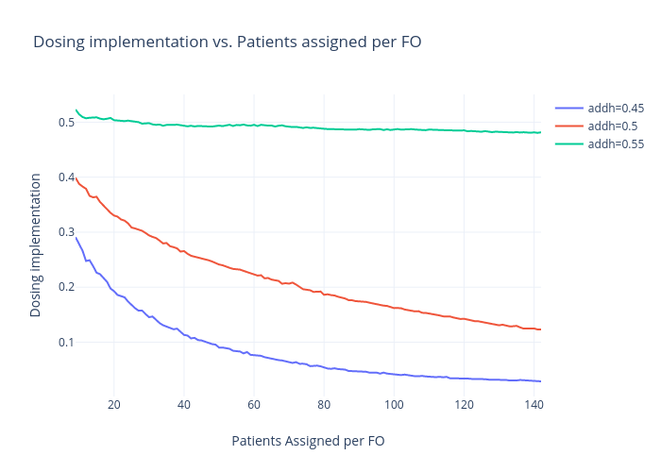

**2. Threshold Days**

*Average Queue Length:*

The patients are added to the queue for FO’s visit once they have crossed the threshold mark of consecutive misses. Therefore, the lower this threshold mark, more are the number of patients that will cross it and enter the queue of pending visits.

As the number of patients in the FO’s visiting queue increases, the more would be the average queue length.

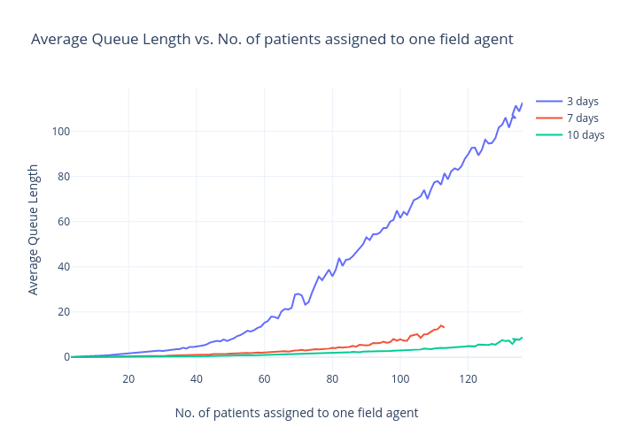

*Average Waiting Time:*

Consecutively, with lowering the threshold and more people entering the queue, the amount of time a person has to spend waiting before his/her turn comes and a visit is made to him/her also increases.

This leads to a natural rise in average waiting time for the patients.

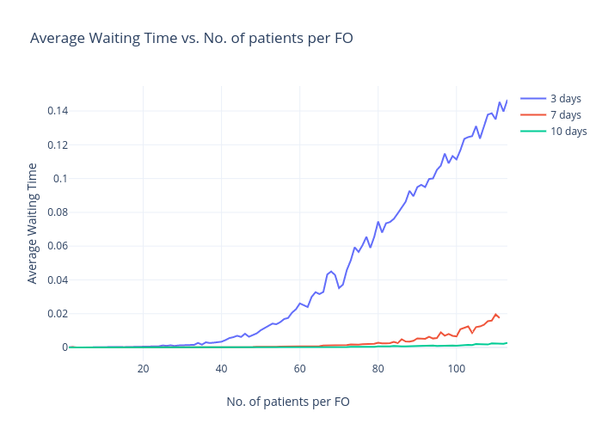

*Dosing Implementation:*

With the change in threshold, there is a stark difference in Dosing Implementation.

If the threshold is n days, a patient enters the visiting queue of the FO after n consecutive misses. As soon as he is visited, his adherence changes permanently to 1 and therefore, the number of patients who have a chance to enter the queue further will go down. The lesser the number ‘n’, the faster will the patient make the continuous misses and get entered into the queue and consecutively after getting visited, will become fully adherent.

If there is a large ‘n’, there is a lesser chance of the patients making these consecutive misses (bernoulli distribution) and hence the state where majority of the patients are fully adherent would reach after long delay. During that time, due to lower adherences, the patients will keep missing the medication and the Dosing Implementation will keep declining.

It is important to note that the Dosing Implementation is not affected by the threshold directly. It is affected by the ability of the threshold changing the adherence of the patients and by what delay does it do so.

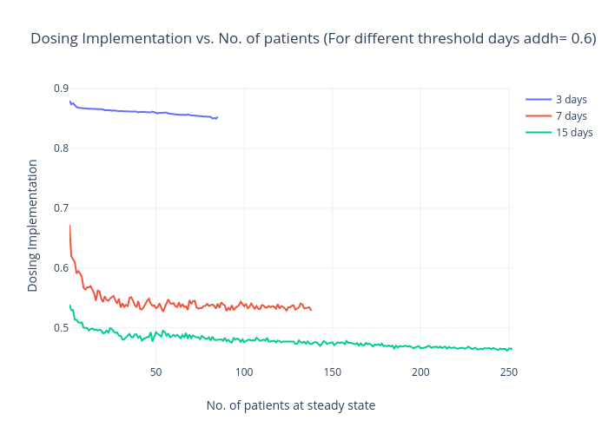

**HOW IS DOSING IMPLEMENTATION AFFECTED?**

Our chief concern out of this activity should be determining the impact of variation of different factors in our control on dosing implementation. A better dosing implementation would be a combination of having a reasonable number of patients assigned to one field agent and a proper policy of n-day consecutive-miss threshold for field visits in area with known adherence.

A higher/adequate dosing implementation in a region due to the field visits and changes in the approach would mean a success for 99DOTS.

|  |
| --- |
| Dosing Implementation = No. of patient days of medicine taken/ Total patient days |

**1. Adherence:**

The total number of missed days directly depend on the adherence of the region, i.e, more the adherence, lesser the missed days and more the Dosing Implementation.



**2. Number of patients assigned to one field agent:**

As the number of patients increase, the lesser will be the rate at which a field visit could be made to them and hence they will have a lesser chance of becoming fully adherent due to delay and overcrowding in the queue. Thus, as the number of patients under the care of a field agent increases, the dosing implementation goes down.

**3. Threshold Days:**

If the threshold is n days, a patient enters the visiting queue of the FO after n consecutive misses. As soon as he is visited, his adherence changes permanently to 1 and therefore, the number of patients who have a chance to enter the queue further will go down. The lesser the number ‘n’, the faster will the patient make the continuous misses and get entered into the queue and consecutively after getting visited, will become fully adherent.

If there is a large ‘n’, there is a lesser chance of the patients making these consecutive misses (bernoulli distribution) and hence the state where majority of the patients are fully adherent would reach after long delay. During that time, due to lower adherences, the patients will keep missing the medication and the Dosing Implementation will keep declining.

It is important to note that the Dosing Implementation is not affected by the threshold directly. It is affected by the ability of the threshold changing the adherence of the patients and by what delay does it do so.

